**Group Members**

Oyindamola Oluyemo

Meghana Nancherla Patel

Maurice Joy

**APP NAME : DEBT TRACKER**

HW3 Version : https://payupapp1.herokuapp.com/

HW4 Version : https://payupapp2.herokuapp.com/

**Issue 1**

**LACK OF FEEDBACKS**

One the main issues facing our application is a lack of feedback at different stages of the application and when performing tasks. This often led to confusion on the person using the application as they become unaware what state the application is.

**A1-Problem Statement from HW4:** After signing up, user didn’t know if the operation was successful or not

**Solution**

We addressed this issue by implementing toast notifications which notifies users with a flash message on the top right corner of the screen about what is going on in the application or the result of an action taken by the user

**Screenshots before fix**

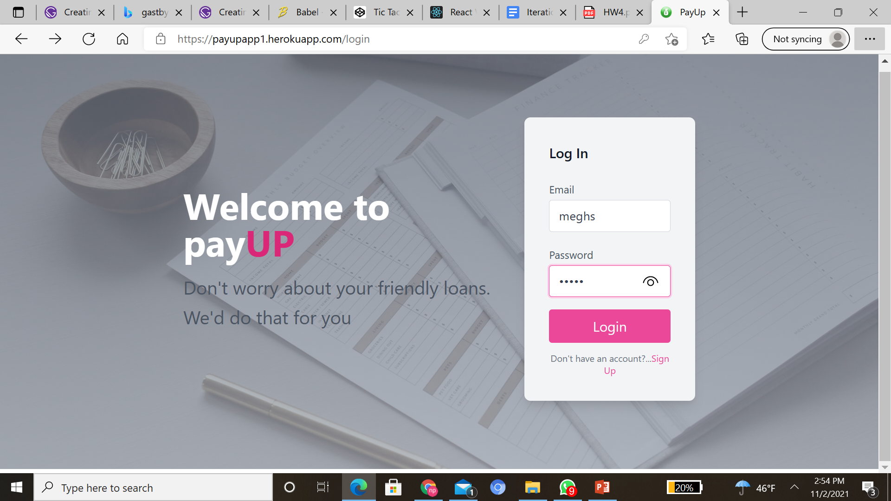

**Screenshots before fix**

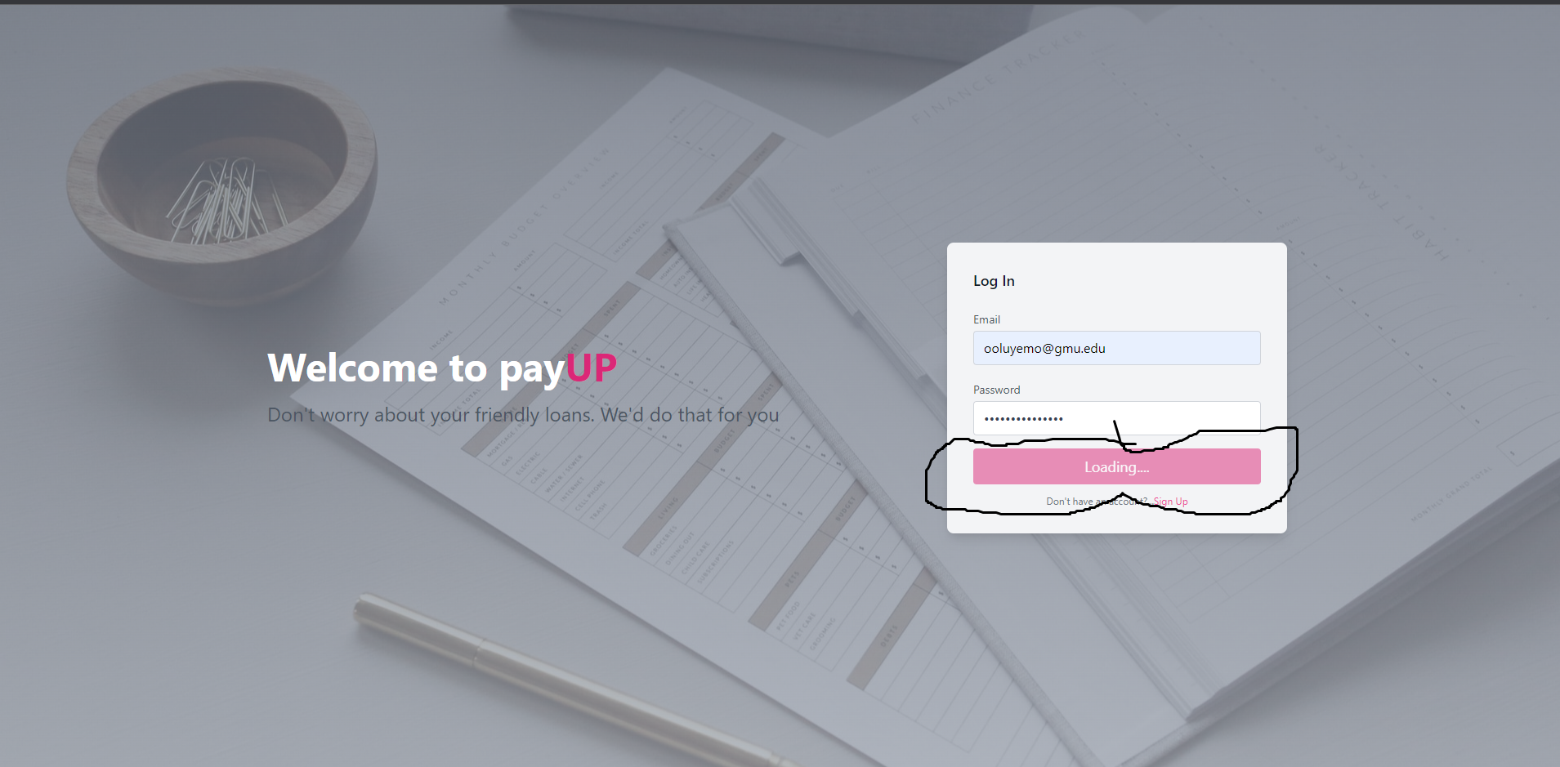

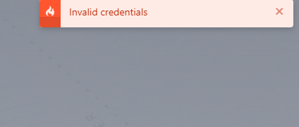

**Issue 2**

**INABILITY TO COMPLETE CORE TASKS/USE CASES**

Another issue users often had with our application was being unable to complete actions like registration, login, adding loanee records, adding quick loans, etc

**- A2-Problem Statement from HW4:** User was unable to add records of people who had collected petty loans from them

**- B2-Problem Statement from HW4:** User was unable to add records of debtors for loan accounting

**- D1-Problem Statement from HW4:** when logged in shows someone else's account.

**-D2-Problem Statement from HW4:** wanted to add debtors to borrow money but couldn't add any debtors.

**Solution**

We addressed this issue by implementing a backend api for our application which can hold user information on a backend database. Also, this enables the users to work with real data instead of the previous dummy data. This particular solution solves two or more usability issues discovered previously on the application.

**Screenshots before fix**

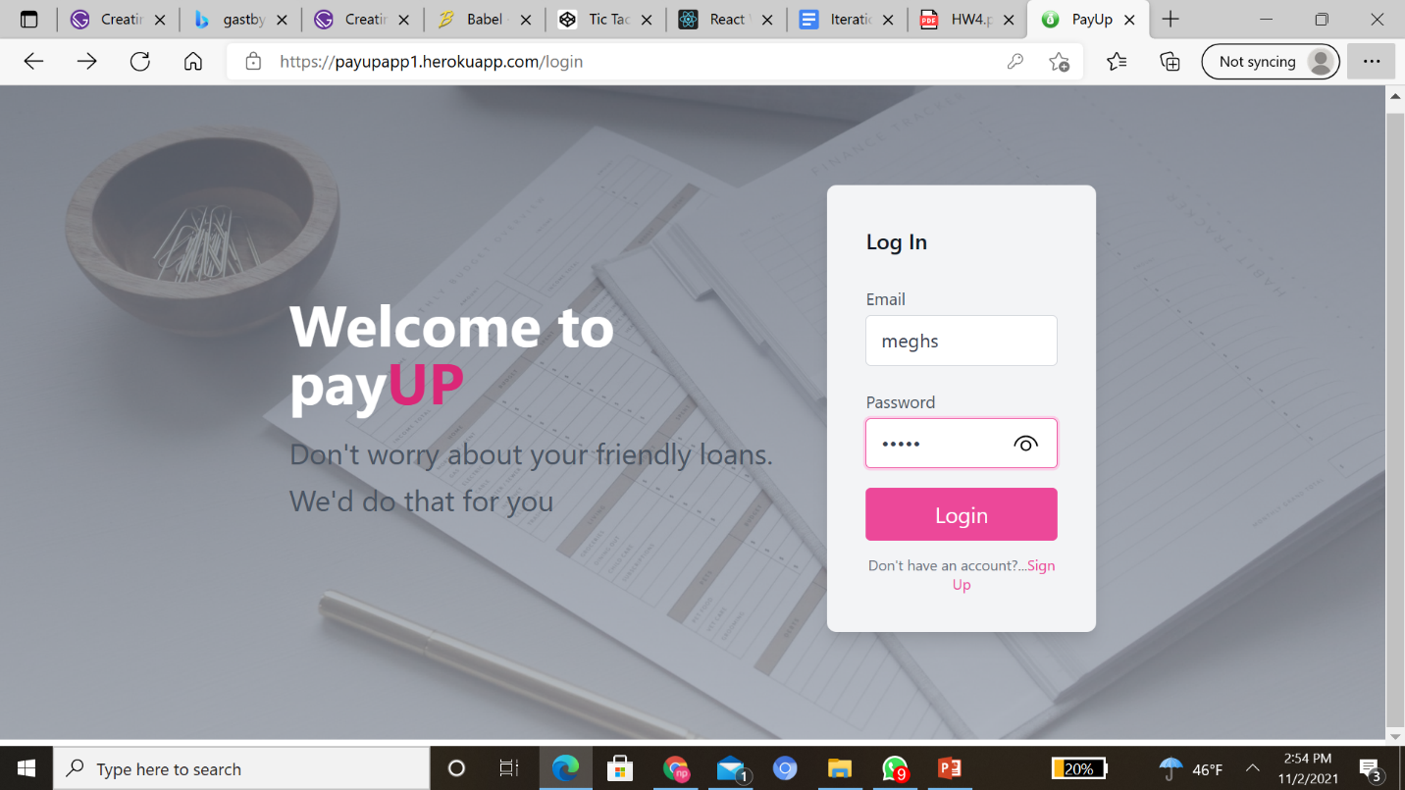

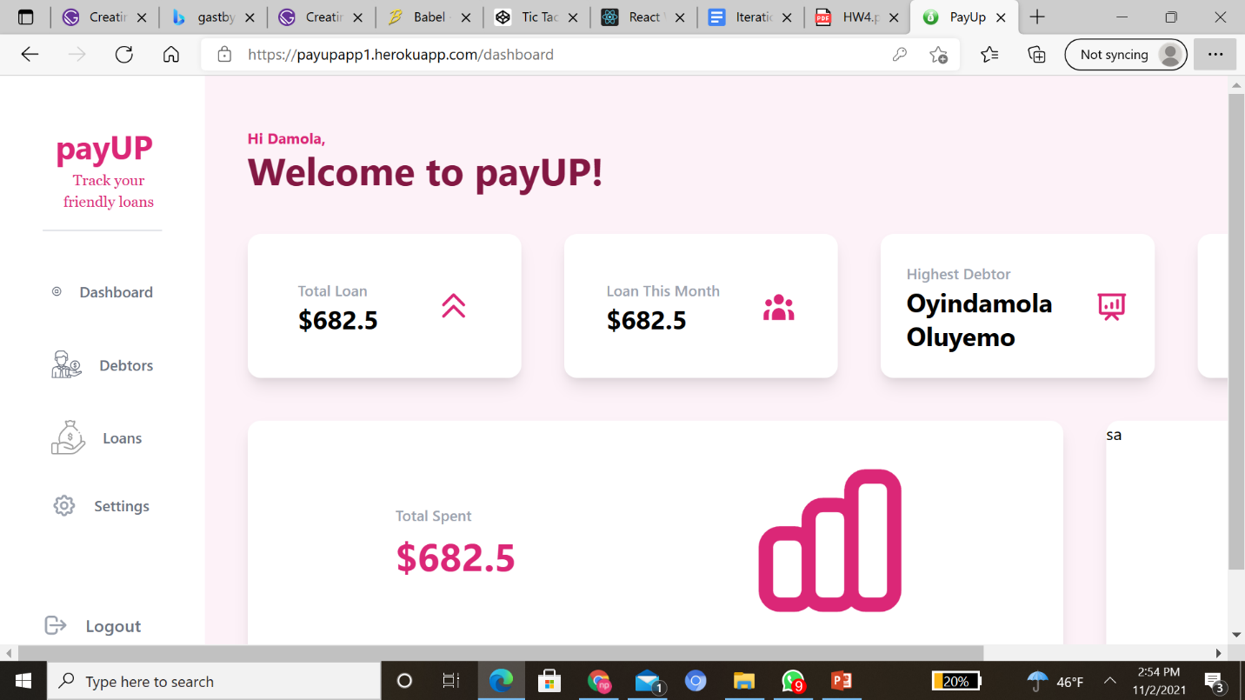

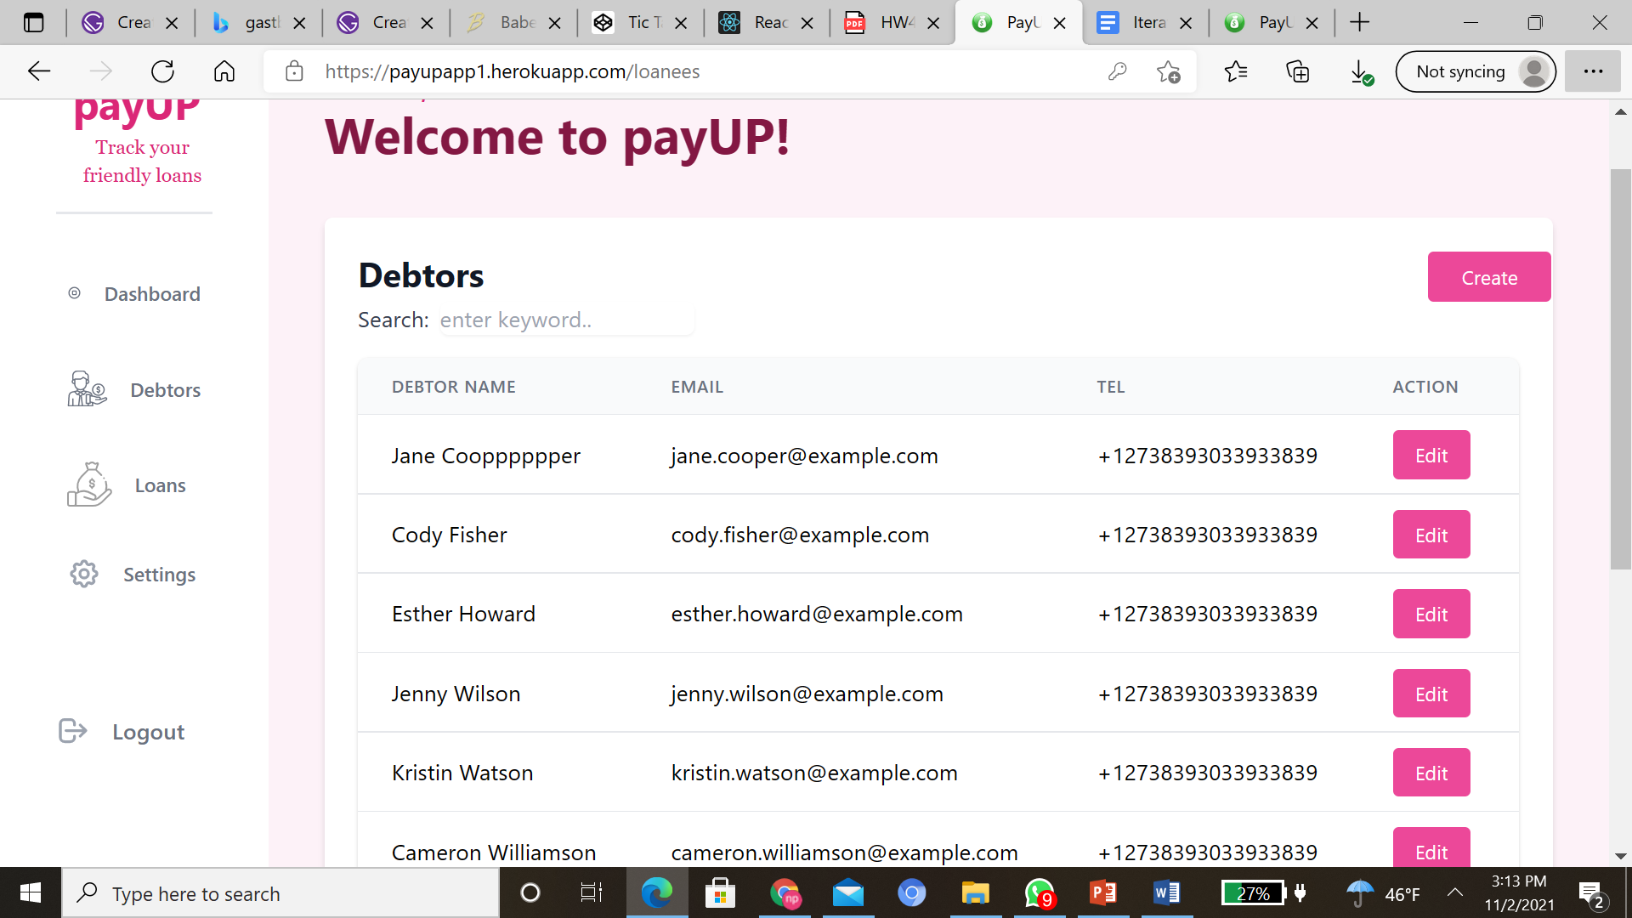

Dummy Data

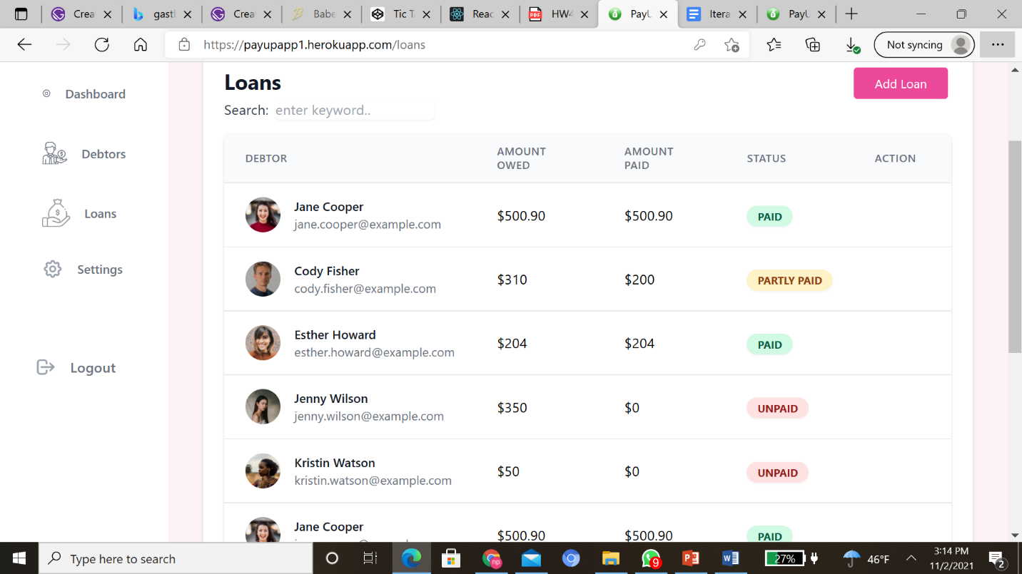

**Screenshots after fix**

